**Single Electron Transistor and Circuit Design**

Name

Institution

Course

Instructor

Date

*Single Electron Transistor and circuit design*

**Abstract**

The recent increase in the relevance of healthcare applications and IoT (Internet of Things) has largely contributed to development of lower power Nano-electronic devices with multiple performances. Ultra-low-power consumption is believed to be one of the most research topics in the current world. For instance, the number of microcomputers used nowadays, e.g., home electronics and mobile phones, utilizes low power. In this case, SET is the best choice in achieving a low power consumption with a higher level of component and device integration. Some of the areas where SET has been integrated include - single-electron spectrophy, super-sensitive electrometers, temperature standards, and voltage state logics. Multiple research in this area shows how SET can revolutionize digital data storage and random access memory. The Single-electron transistor alias (SETs) in digital electronics is a lower power device suitable for nanoscale circuitry in the future of nanotechnology. SET controls the transport of single charges off and on a metallic instrument. SETs are known to give new ideas expected to revolutionize digital storage technologies and the RAM (random access memory).

This research paper aims to discuss the step-by-step performance analysis of SET, its design description, and its impact on people's lives in various sectors. Coulomb blockade's operation is determined by an energy barrier used to determine the flow of current through a specific device in a metallic island. The effect of the Coulomb blockade prevents any single transfer between coulomb barriers and Middle Island. This condition causes zero-conductance and low biasing, although this limitation can be solved using multiple islands in the Single Electron Transistor structure since the materials consist of two-dimensional carbon materials, e.g., graphene. An increase in the number of islands also increases the probability of tunneling - a factor known to raise the electron and reduce the conductance gap in SET. Several analyses can be done in the carbon materials – graphene double Quantum dots (modeling and analysis).

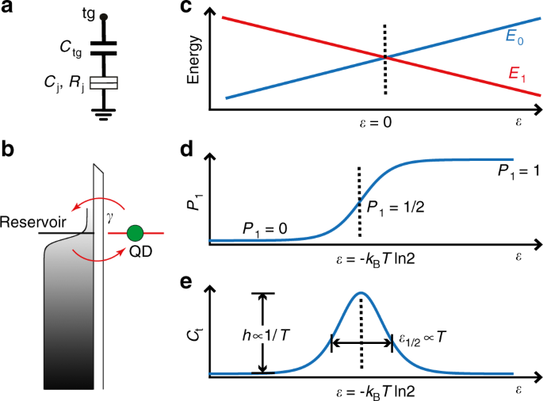

**Image 1.1:** diagram representing Quantum dot

Thus, the graphene effect on its length can be done on temperature, current, and gate voltage of SET. The effect on the number of islands in the SET current can be evaluated with respect to the charge stability diagram – a final result of the Single Electron Transistor (SET) simulation. A Single Electron Transistor is usually a key element in current research and analysis in nanotechnology known to offer high operating speed and low power consumption. SET uses a new technique of switching consisting of controlled electron tunneling for amplifying current. Since the Coulomb blockade determines the SET operation principle, regulating the device's charge can modify and affect the Coulomb blockade (Dubuc et al., 2018).

For this reason, SET can be used as an electrometer in RF and DC modes. Theoretically, charge sensitivity of values lower than 0.0000017 el/ Hz gives an experimental value of 0.000012 e/ Hz. Thus, the experimental values of the SET are known to be a thousand better than the FET, field-effect transistor.\

**Keywords: - SET**, Single Effect Transistor, single effect tunneling, quantum dot, Coulomb oscillation, and Coulomb blockade.

**Introduction**

           Over the past 40 years, Nano and micro have been obeying Moore’s law. However, miniaturization in microelectronics has brought electronic devices and equipment on a scale close to the size of a quantum phenomenon dominating devices' operation while changing their properties. Quantum effects are not certainly a downside to the electronic industry due to the capability to create their own independent devices. Science and technology have already entered a new technology field expected to be the future of modern electronics. Nanoscience is one of the significant areas dealing with the design of nanoscale devices referred to as Nano-devices. Nano-devices are known to function the same as today's micro-scale devices, e.g., FETs, although their physical working principles are very different. SET is believed to be one of the most fascinating and promising Nano-devices. SET is yet the most powerful device which exploits the quantum mechanical phenomenon of tunneling and still acts as an amplifier and a switch as well, just like FETs. However, it directs and controls the transport of single electrons. Therefore, it is more interesting to examine and research the device's functional properties while looking at the best area of application. Unlike FET, SET can be used in amplifier mode to measure charge and variation of the specific system's charge, thus used as an electrometer. According to Schoelkopf and Devoret SET is believed to be one of the most suited devices to be used as an electrometer since it has a high charge sensitivity and energy, which account for the theoretical quantum limit (Kumar & Kaur, 2019). This research paper aims to answer these questions: how SET as an optimal device is able to function as an ultra-sensitive electrometer, and how is it unique from other transistors, basing my argument on efficiency and functionality. This research paper will examine the functional principle of SETs and later describe its application as an ultra-sensitive electrometer and as a functional quantum Nano-device.

**Description of the SET and its circuit design**

           Single-electron transistor, commonly known as SET, comprises of multiple islands connected closely together through tunneling junction to a source and a drain and a capacitor to an electrode gate. Whenever there is no bias in the electrodes, electrons will have enough tunneling energy through the main junction. On the other hand, a typical field-effect transistor (FET) works as a switch by turning on and off when an electron is passed through the semiconductor or removed from the semiconductor. Like FET, turning on and off the semiconductor states brings about ones (1) and zeros (0), the key components used by most digital computers. Transistors, interestingly, are the most classical components in physics. Only a few of them can characterize the property of quantum mechanics. Whenever one is making a transistor, they should ensure that the electrons are confined to communicate with other electrical leads through tunneling. SET is one of the transistors that turn off and on every time an electron is added.

**Circuit design diagram**

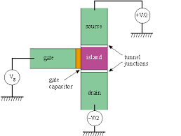

**Image 1.2:** Circuit diagram of Single electron transistor

           In SET alias single electron transistor, source and drain electrode are usually connected through a tunnel junction to a middle island – capacitively connected to an electrode gate. Whenever all the biases are zero, electrons will never have enough energy to tunnel over the junction. Therefore, whenever you increase the bias while keeping it below the coulomb voltage gap, an increase in the bias gate beyond the point of maximum will cause zeros and ones to have the same energy, removing the Coulomb barrier allowing more electrons to be tunneled through its junction and between the drain and the source.

Therefore the Coulomb energy can be expressed as:-

**Ec= e2 / 2C.**

Where E represents the charge of an electron, and C the capacitance of the drain and source junction and the gate capacitor. When the drain and source bias is greater than e/C across the junction (e/2C), also known as a coulomb voltage gap, electrons will actively tunnel through the junctions causing current to flow through the transistor of the bias gate. When quantizing the electron flow, or Coulomb staircase, the thermal energy must be not more than the Coulomb energy (Uchida et al., 2020). As the voltage of the gate increases, the current is expected to increase in quantized chunks. Therefore for a single electron transistor to function properly at room temperature.

kT<<e2/2C

C<<e2/2 kT ≈3.09*10-18F

The capacitance denoted by C must be less than 3.09x10-18 Farads. The capacitance C is related to the distance between the two sides of the junction by: -

C<<3.09×10−18F 🡺d<10 nm

Therefore the diameter d of the island must be equal to or less than 10 nanometers. The transistor's mode of operation occurs when the drain and the source's bias are less than the coulomb voltage gap. When the gate bias is raised to the point of correspondence with the maximum slope on the coulomb staircase, the island configuration with one or zero excess of an electron will have equal energies. Thus, allowing tunneling to occur while removing the barrier. The maximum can only be achieved when the gate is charged with a minus half of an electron from the beam. When an additional negative half of the electrons are added to the gate, the coulomb barrier will be reinstated, and the result will be an oscillation relative to transistor conductance with maxima at half the multiple integers of e and respective minima at the multiple integers of e. The oscillation obtained from the conductance can only allow a SET to be used as either a device for measuring and gauging charge or as a transistor.

Various types of materials are usually chosen for SET based on different and specific properties present in a system. Some of these properties include the ease of the growing oxide layers, electron mobility, the capacitance of material, and ease in fabricating a material. Thus, the single-electron transistors can be classified as either semiconductor or metallic depending on the fabricating material, although both operate through tunneling.

**Numerical simulation and implementation of SET at design level using MATLAB**

The SET's equations in this research paper can be implemented in MATLAB. The following are series of MATLAB code to be used to produce respective graphs and plots.

q=1.602e-19; % electronic charge (C)

kb=1.381e-23; % Boltzman constant (J/K) % Definition of Device parameters

c1=1.0e-20; % tunnel capacitor C1 (F)

c2=2.1e-19; % tunnel capacitor C2 (F)

cg=1.0e-18; % gate capacitor Cg (F)

ctotal=c1+c2+cg; % total capacitance (F)

mega=1000000; % definition of mega=106

r1=15*mega; % tunnel resistance R1 (Ohm)

r2=250*mega; % tunnel resistance R2 (Ohm)

%PART ONE COMPLETE

Vg=0; % gate voltage (V)

q0=0; % background charge q0 is assumed to be zero

temp=10; % temperature T (K)

vmin=-0.5; % drain voltage minimum Vmin (V)

vmax=0.5; % drain voltage maximum Vmax (V)

NV=1000; % number of grid from Vmin to Vmax

dV=(vmax-vmin)/NV; % drain voltage increment of each grid point

for iv=1:NV % loop start for drain voltage

%PART TWO COMPLETE

V(iv)=vmin+iv*dV; % drain voltage in each grid point%

Nmin=-20; % minimum number of N (charge number in dot)

Nmax=20; % maximum number of N (charge number in dot)

for ne=1:Nmax-Nmin % loop start for N

n=Nmin+ne; % N charge number in dot

dF1p=q/ctotal*(0.5*q+(n*q-q0)-(c2+cg)*V(iv)+cg*Vg);

dF1n=q/ctotal*(0.5*q-(n*q-q0)+(c2+cg)*V(iv)-cg*Vg);

dF2p=q/ctotal*(0.5*q-(n*q-q0)-c1*V(iv)-cg*Vg);

dF2n=q/ctotal*(0.5*q+(n*q-q0)+c1*V(iv)+cg*Vg);

% Noted that loop end for N is located after calculation of

%PART THREE COMPLETE

if dF1p<0

T1p(ne)=1/(r1*q*q)*(-dF1p)/(1-exp(dF1p/(kb*temp))); %? positive in equation

else

T1p(ne)=1e-1; % positive is assumed to be very small

end

if dF1n<0

T1n(ne)=1/(r1*q*q)*(-dF1n)/(1-exp(dF1n/(kb*temp))); % ? negative in equation

else

T1n(ne)=1e-1; % negative is assumed to be very small

end

if dF2p<0

T2p(ne)=1/(r2*q*q)*(-dF2p)/(1-exp(dF2p/(kb*temp))); % ? positive in equation (26b)

else

T2p(ne)=1e-1; % positive is assumed to be very small

end

if dF2n<0

T2n(ne)=1/(r2*q*q)*(-dF2n)/(1-exp(dF2n/(kb*temp))); % negative equation

else

T2n(ne)=1e-1; % negative is assumed to be very small

end

end

%PART FOUR COMPLETE

p(1)=0.001; % ?(Nmin) is assumed to be 0.01

p(Nmax-Nmin)=0.001; % ?(Nmax) is assumed to be 0.01Sixth, normalization of ? is done. Here, ?????????? is calculated.

sum=0; % sum=0 is initial value to calculate ?

for ne=2:Nmax-Nmin

p(ne)=p(ne-1)*(T2n(ne-1)+T1p(ne-1))/(T2p(ne)+T1n(ne)); % calculation of ?(N) in equation (28)% The conditions below are used to avoid divergence of Matlab calculation

if p(ne)>1e250

p(ne)=1e250;

end

if p(ne)<1e-250

p(ne)=1e-250;

end

% ---------------------

sum=sum+p(ne);

end

for ne=2:Nmax-Nmin

p(ne)=p(ne)/sum; % Normalization in equation

end

%PART FIVE COMPLETE

sumI=0; % sumI=0 is initial condition for current calculation

for ne=2:Nmax-Nmin

sumI=sumI+p(ne)*(T2p(ne)-T2n(ne));

end

I(iv)=q*sumI; % I in equation of drain voltage loop

end

plot(V,I); % plot of I vs V

for iv=1:NV-1

dIdV(iv)=(I(iv+1)-I(iv))/dV; % calculation of dIdV

end

figure;

plot(V(1,1:NV-1),dIdV); % plot of dIdV vs V

%PART SIX COMPLETE

The numerical simulation of a single electron transistor depends on the mentioned equations, useful for both research and educational purposes. The simulated results should produce a staircase behavior in the current-voltage drain characteristic and periodic oscillations in the gate voltage characteristic

**MATLAB results**

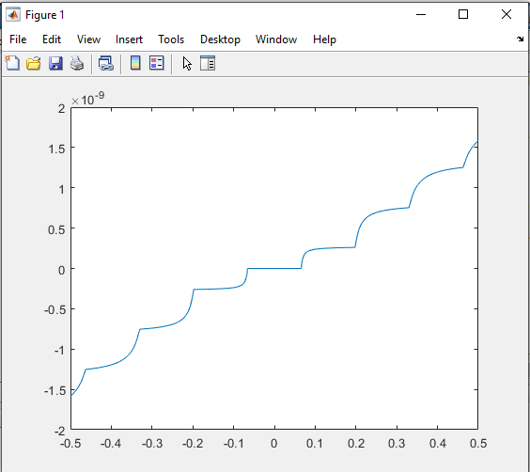

**Graph 1.1:** representing gate voltage against current, I

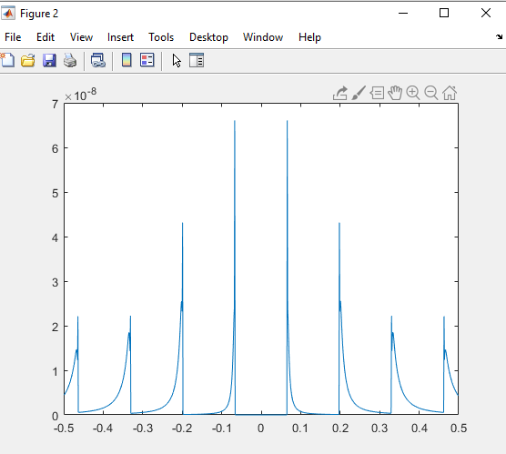

**Graph 1.2:** representing current against gate voltage and drain voltage

**Performance analysis**

SET controls the flow of current between the source and the drain via gate electrode, just like FET. However, the behavior of SET depends only on the transport of a single elementary charge and gate voltage which controls it through the Coulomb blockade. Whenever the Coulomb voltage is overcome, one electron will be tunneled from the source to the middle island while adding one extra electron. The process of tunneling occurs between Middle Island and the drain. The source energy and the draining energy usually depend on the potential difference existing between VS and VD. Whenever the charging energy goes from n to n+1, the extra electron(s) will always depend on the VG, the gate voltage.

$$En+1-En=(n+\frac{1}{2}-\frac{VcCc}{q})\frac{e2}{CΣ}$$

By adding any extra electron on the middle island either unfavorable or favorable will depend on the gate charge which in turn will depend on the gate voltage. As evident in the above equation, the gate charge is equal to the integer values of the charge e and the coulomb blockade will always be active with no conduction. Since the system has minimum energy, the middle island will always have well defined number of charges and tunneling will always increase the global energy of the system. Under this condition the coulomb blockade will always be active and there will be no tunneling of electrons in and out of the middle island. The transistor will always be active (in conducting state) if the charge at the gate is equal to the integer values known to be half of the charge QC where N is an integer value. The system should have a minimum energy ranging between two states with a well distinct elementary charge. It will cause a cascade tunneling of events involving two state junction, to sequentially give rise to a current in between the source and the drain. This process can be represented graphically and viewed as an energy picture of coulomb blockade and conduction modes of the SET. The image below represents blocking state and conducting state of Single Electron Transistor (Averin & Likharev, 2019).

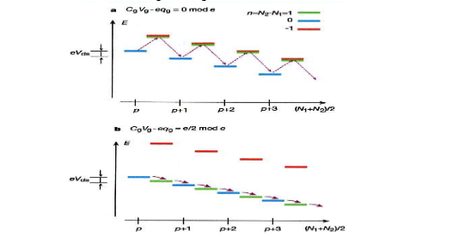

**Image 1.3:** graphical representation of coulomb blockade

By representing the charging energy against the charge present in the middle island, n. The charge present is an integer value representing the coulomb blockade will be at different states – maybe active or inactive states. If the charge is ½ the single electron transistor will be in full conduction mode. The process can be represented in a diagram as follows.

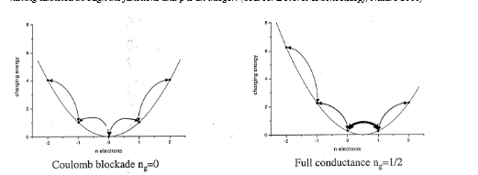

**Image 1.4:** representing charging energy against the charge present in the middle island

The voltage conditions to make tunneling possible can be expressed in term of capacitance. We will examine a case when VG, gate voltage is zero. When there is no excess electron in the island, n=0 and no voltage at the gate, then the V**DS, T,** should be equal to:

V**DS, T, =**

Where e is the charge of 1 electron, CR and CL the capacitance at the right and left tunneling junction, respectively. CΣ is the total capacitance, and CG is the gate capacitance. The threshold voltage is a very important quantity. It is known as the minimal source-drain voltage necessary to overcome the blockade to allow current to flow through the single-electron transistor. Thus, to achieve a constant current flow, the V**DS** potential energy must be relatively higher than e2/2 CΣ. To lower the threshold voltage to zero, we increase the gate's voltage, thus reducing the blockade. The voltage between the source and the drain depends on the voltage at the gate (Dubuc et al., 2018).

V**DS =**

Current is expected to flow if and only if the voltage, V**DS** higher or equal to the threshold voltage, V**DS, T.** Therefore, the gate voltage should be there to lower the threshold voltage.

It is expressed as:-

VG (V**DS, T, =**  =

From the above equation, it is clear that the condition above that the charges at the gate (QG= VGCG) must be equal to one-half the value of charge in agreement with the conditions set for conduction via the single-electron transistor.

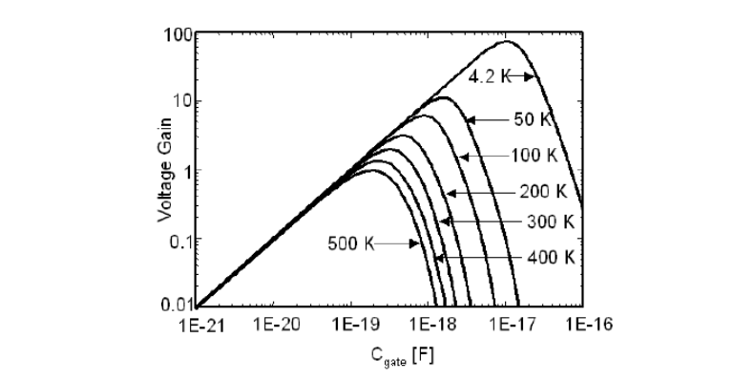

**Image 1.5**: representing a voltage gain of single electron transistor of gate capacitance

Thus, it will be easy to derive the four characteristics of a single electron transistor depicted in the figure below. SET is believed to be symmetrical within the zero point. When VG = 0, the current should start flowing when the threshold voltage is attained. There is a gap between the –V**DS and**V**DS**(coulomb gap) where current cannot flow and usually comes as a consequence of the Coulomb blockade. When VG is present, the threshold voltage is always equal to zero, and the IV- characteristic will always present a no gap as there is no Coulomb blockade.

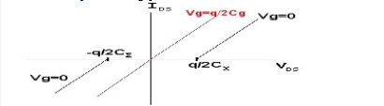

**Image 1.6:** represents the IV-characteristic of the single electron transistor.

The IDS current comes from the flow of electrons between the source and the drain. The electrons are tunneled from the source to the drain, creating a current between them. One should keep in mind that although the current may be flowing, the middle island's excess electrons are always constant. The electrons are tunneled from the source to the island and from the island to the drain. Thus, keeping the number of extra electrons unchanged but will create a current. This process is not the same as co-tunneling – where electrons are tunneled simultaneously from the source to the middle island and from the middle island to the drain.

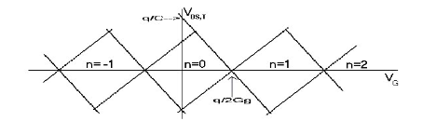

**Image 1.7:** representing the stability diagram of the SET

**Need for future improvement**

The future works will involve creating a tunnel junction for a single electron transistor for defining drain, source, and the middle island in a silicon substrate. We can use pattern-dependent oxidation (PADOX) to create a tunnel junction, which will involve the growth of oxide by dry oxidation to reduce the tunnel junction's width in N-type silicon, which LPCVD will deposit to create a control gate.

**Conclusion**

SET is one of the most interesting Nano-devices taking over other transistors' functions and operations, e.g., FET. From our review, it is clear that a single electron transistor's sensitivity is always high - approximately 1.7 x 10-6e/Hz1/2. However, some of the conditions applied to the optimal devices may not be realistic. The optimal value chosen for resistance and capacitance can be easily modified or obtained using modern lithography. The Coulomb blockade value can be easily set by changing the source-drain and gate voltage values. The blockade value is always optimally set at a reasonable temperature where the interference, according to Nyquist noise, is negligible. This optimal value is usually practically achieved from temperatures below 1k.

The ultra-sensitivity of a single-electron transistor as an electrometer shows that SET is a seamless tool to measure the variation charges in various nanoscale systems since the optimal value of FET is 1100 times worse than SET. A single electron transistor electrometer's ability to measure quantum systems makes it a perfect tool when matched with other transistors, e.g., qubits (Steele et al., 2019).

**Appendix A**

MATLAB simulation procedure

1. Defining the device and physical parameters
2. Input the external parameters (V, Vg, Q0 and T)
3. Calculating the ΔF
4. Observing whether ΔF is positive or negative
5. Calculating ρ
6. Normalizing ρ
7. Calculating I, current
8. Plotting the graphs whenever V>Vmax

References

Averin, D. V., & Likharev, K. K. (2019). Coulomb blockade of single-electron tunneling, and coherent oscillations in small tunnel junctions. *Journal of low temperature physics*, *62*(3), 345-373.

De Franceschi, S., Van Dam, J. A., Bakkers, E. P. A. M., Feiner, L. F., Gurevich, L., & Kouwenhoven, L. P. (2018). Single-electron tunneling in InP nanowires. *Applied Physics Letters*, *83*(2), 344-346.

Dubuc, C., Beauvais, J., & Drouin, D. (2018). A nanodamascene process for advanced single-electron transistor fabrication. *IEEE transactions on nanotechnology*, *7*(1), 68-73.

Kumar, O., & Kaur, M. (2019). Single electron transistor: Applications & problems. *Int J VLSI Des Commun Syst (VLSICS)*, *1*(4), 24-29.

Steele, G. A., Hüttel, A. K., Witkamp, B., Poot, M., Meerwaldt, H. B., Kouwenhoven, L. P., & van der Zant, H. S. (2019). Strong coupling between single-electron tunneling and nanomechanical motion. *Science*, *325*(5944), 1103-1107.

Uchida, K., Matsuzawa, K., Koga, J., Ohba, R., Takagi, S. I., & Toriumi, A. (2020). Analytical single-electron transistor (SET) model for design and analysis of realistic SET circuits. *Japanese Journal of Applied Physics*, *39*(4S), 2321.